From https://en.0wikipedia.org/index.php?q=aHR0cHM6Ly9lbi53aWtpcGVkaWEub3JnL3dpa2kvTWF4aW11bV9wb3dlcl9wb2ludF90cmFja2luZw

This is a dynamic quantity which changes depending on the level of illumination, as well as other factors such as temperature and the age of the cell. If the resistance is lower or higher than this value, the power drawn will be less than the maximum available, and thus the cell will not be used as efficiently as it could be. Maximum power point trackers utilize different types of control circuit or logic to search for this point and thus to allow the converter circuit to extract the [maximum power](https://en.0wikipedia.org/index.php?q=aHR0cHM6Ly9lbi53aWtpcGVkaWEub3JnL3dpa2kvSW1wZWRhbmNlX21hdGNoaW5nI1Bvd2VyX3RyYW5zZmVy) available from a cell.

1. MPPT Implementation[[edit](https://en.0wikipedia.org/index.php?q=aHR0cHM6Ly9lbi53aWtpcGVkaWEub3JnL3cvaW5kZXgucGhwP3RpdGxlPU1heGltdW1fcG93ZXJfcG9pbnRfdHJhY2tpbmcmYWN0aW9uPWVkaXQmc2VjdGlvbj0y" \o "Edit section: MPPT Implementation)]

When a load is directly connected to the solar panel, the operating point of the panel will rarely be at peak power. The impedance seen by the panel derives the operating point of the solar panel. Thus by varying the impedance seen by the panel, the operating point can be moved towards peak power point. Since panels are DC devices, DC-DC converters must be utilized to transform the impedance of one circuit (source) to the other circuit (load). **Changing the duty ratio of the DC-DC converter results in an impedance change as seen by the panel.** At a particular impedance (or duty ratio) the operating point will be at the peak power transfer point. The I-V curve of the panel can vary considerably with variation in atmospheric conditions such as radiance and temperature. Therefore it is not feasible to fix the duty ratio with such dynamically changing operating conditions.

MPPT implementations utilize algorithms that frequently sample panel voltages and currents, then adjust the duty ratio as needed. Microcontrollers are employed to implement the algorithms. Modern implementations often utilize larger computers for analytics and load forecasting.

MPPT implementations utilize algorithms that frequently sample panel voltages and currents, then adjust the duty ratio as needed. **Microcontrollers** are employed to implement the algorithms. Modern implementations often utilize larger computers for analytics and load forecasting.

There are different methods one of which is perturb and observe, it is the easiest to implement. However it creates oscillations in the power.

1. MPPT placement[[edit](https://en.0wikipedia.org/index.php?q=aHR0cHM6Ly9lbi53aWtpcGVkaWEub3JnL3cvaW5kZXgucGhwP3RpdGxlPU1heGltdW1fcG93ZXJfcG9pbnRfdHJhY2tpbmcmYWN0aW9uPWVkaXQmc2VjdGlvbj05" \o "Edit section: MPPT placement)]

Traditional [solar inverters](https://en.0wikipedia.org/index.php?q=aHR0cHM6Ly9lbi53aWtpcGVkaWEub3JnL3dpa2kvU29sYXJfaW52ZXJ0ZXI) perform MPPT for the entire PV array (module association) as a whole. In such systems the same current, dictated by the inverter, flows through all modules in the string (series). Because different modules have different I-V curves and different MPPs (due to manufacturing tolerance, partial shading,[[24]](https://en.0wikipedia.org/index.php?q=aHR0cHM6Ly9lbi53aWtpcGVkaWEub3JnL3dpa2kvTWF4aW11bV9wb3dlcl9wb2ludF90cmFja2luZyNjaXRlX25vdGUtMjQ) etc.) this architecture means some modules will be performing below their MPP, resulting in lower efficiency.[[25]](https://en.0wikipedia.org/index.php?q=aHR0cHM6Ly9lbi53aWtpcGVkaWEub3JnL3dpa2kvTWF4aW11bV9wb3dlcl9wb2ludF90cmFja2luZyNjaXRlX25vdGUtc2NpYW0tMjU)

**Some companies (see [power optimizer](https://en.0wikipedia.org/index.php?q=aHR0cHM6Ly9lbi53aWtpcGVkaWEub3JnL3dpa2kvUG93ZXJfb3B0aW1pemVy" \o "Power optimizer)) are now placing maximum power point tracker into individual modules, allowing each to operate at peak efficiency despite uneven shading, soiling or electrical mismatch**.

Data suggests having one inverter with one MPPT for a project that has east and west-facing modules presents no disadvantages when compared to having two inverters or one inverter with more than one MPPT.[[26]](https://en.0wikipedia.org/index.php?q=aHR0cHM6Ly9lbi53aWtpcGVkaWEub3JnL3dpa2kvTWF4aW11bV9wb3dlcl9wb2ludF90cmFja2luZyNjaXRlX25vdGUtMjY)

Charging may begin at a voltage considerably below the PV panel maximum power point voltage, and an MPPT can resolve this mismatch.

When battery is full:

***When the batteries in an off-grid system are fully charged and PV production exceeds local loads, an MPPT can no longer operate the panel at its maximum power point as the excess power has no load to absorb it. The MPPT must then shift the PV panel operating point away from the peak power point until production exactly matches demand. (An alternative approach commonly used in spacecraft is to divert surplus PV power into a resistive load, allowing the panel to operate continuously at its peak power point.)***

In a grid connected photovoltaic system, all delivered power from solar modules will be sent to the grid. Therefore, the MPPT in a grid connected PV system will always attempt to operate the PV modules at its maximum power point.

+++++++++++++++++++++++++++++++++++++++++++++++++++++++++++++++++++++++++++++++

From

https://en.0wikipedia.org/index.php?q=aHR0cHM6Ly9lbi53aWtpcGVkaWEub3JnL3dpa2kvSGlsbF9jbGltYmluZw

In numerical analysis, **hill climbing** is a [mathematical optimization](https://en.0wikipedia.org/index.php?q=aHR0cHM6Ly9lbi53aWtpcGVkaWEub3JnL3dpa2kvT3B0aW1pemF0aW9uXyhtYXRoZW1hdGljcyk) technique which belongs to the family of [local search](https://en.0wikipedia.org/index.php?q=aHR0cHM6Ly9lbi53aWtpcGVkaWEub3JnL3dpa2kvTG9jYWxfc2VhcmNoXyhvcHRpbWl6YXRpb24p). It is an [iterative algorithm](https://en.0wikipedia.org/index.php?q=aHR0cHM6Ly9lbi53aWtpcGVkaWEub3JnL3dpa2kvSXRlcmF0aXZlX2FsZ29yaXRobQ) that starts with an arbitrary solution to a problem, then attempts to find a better solution by [incrementally](https://en.0wikipedia.org/index.php?q=aHR0cHM6Ly9lbi53aWtpcGVkaWEub3JnL3dpa2kvSW5jcmVtZW50YWxfaGV1cmlzdGljX3NlYXJjaA" \o "Incremental heuristic search)changing a single element of the solution. If the change produces a better solution, an incremental change is made to the new solution, repeating until no further improvements can be found.

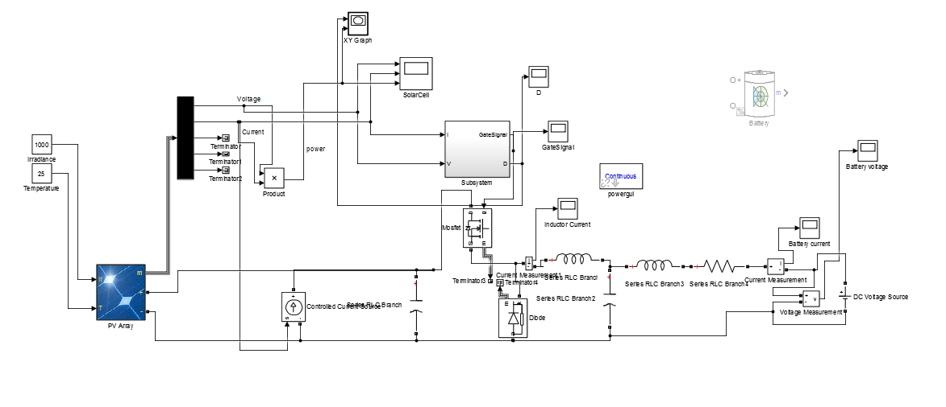

Instead of the defined chargable battery, I simulated first with the dc source as in Psim to observe the similarity. Owever, this time it is important to note that I am using a solar panel cell which has the I-V characteristic defined and a controller. The output of thismodel is:

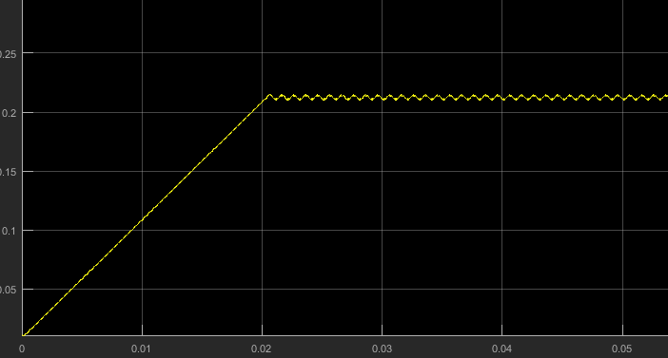

Figure Duty Cycle-Time

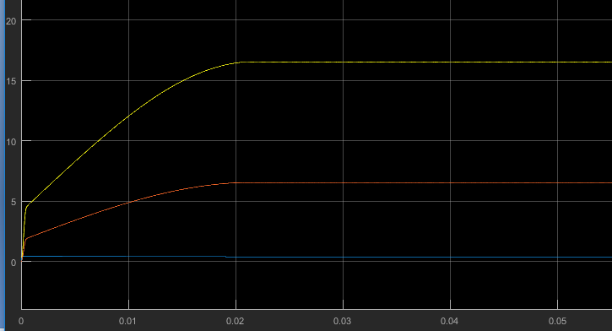

Figure Time-Current-Power-Voltage (from down to up)

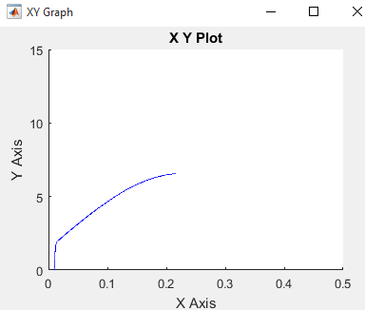

Figure D vs Power

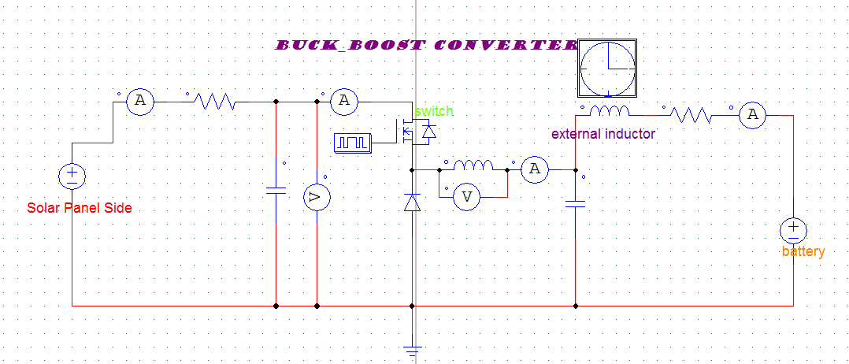

Psim Model(without a controller and a dc voltage instead of a solar panel, it is important to note that panel needs to be modeled as a controlled current source so this model is a basic one)

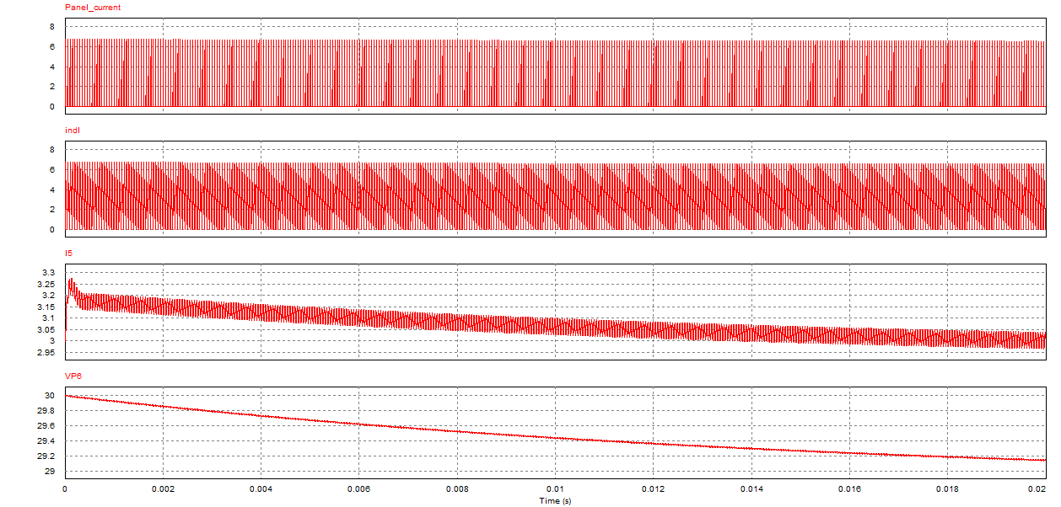

Psim simulation results

Here, there are differences in the Maximum voltage of the two simulations.!